|  |  |
| --- | --- |
| Bug Number | #1 |
| Title | Notification preference isn’t found |
| Reproducible Steps | Open the application – click on three dots on the top right – General settings |
| Affected Devices | IOS |
| Network | Wi-Fi |
| Severity | Minor |
| Priority | High |
| Description | Users can’t set up notifications as a reminder for upcoming bills. |

Attachments:

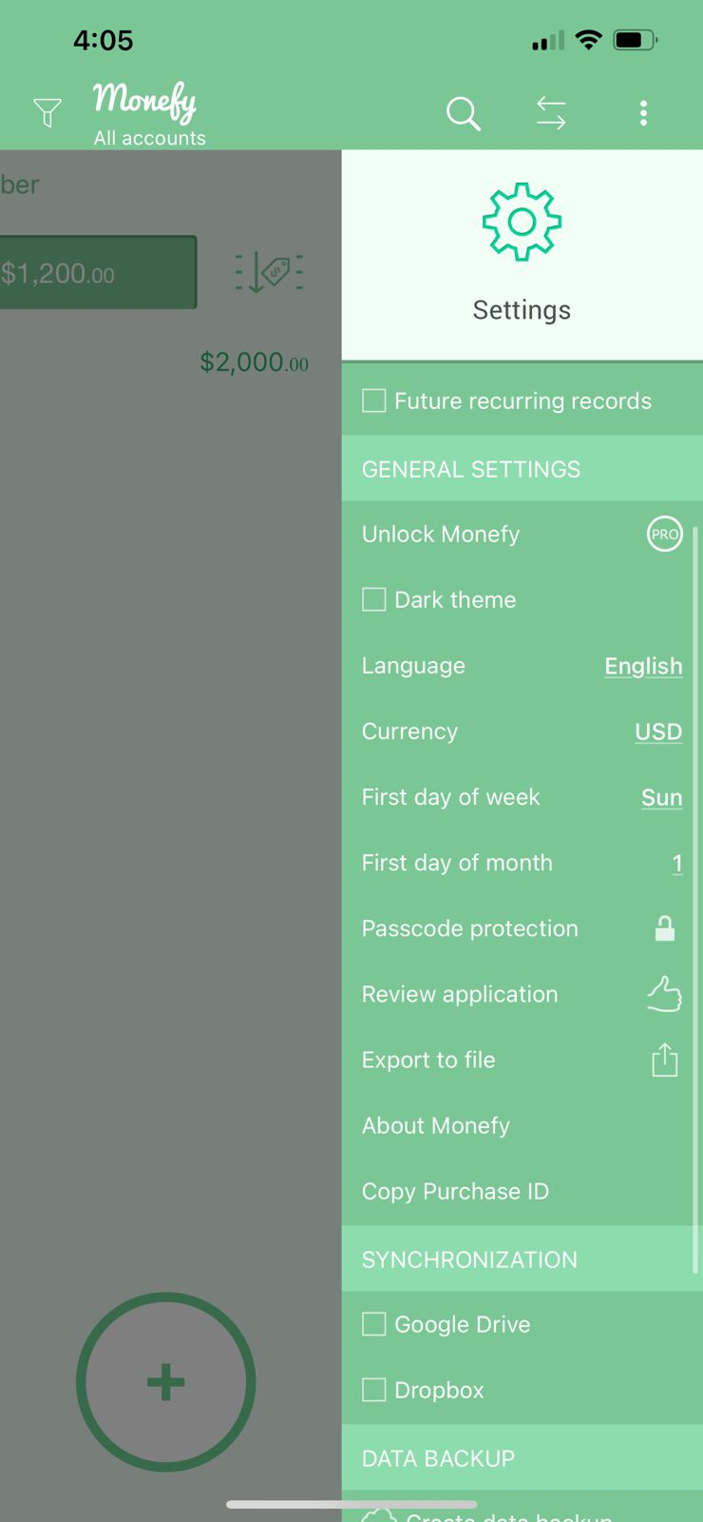

|  |  |
| --- | --- |
| Bug Number | #2 |
| Title | Login page is required. |
| Reproducible Steps | Open the application. |
| Affected Devices | IOS |
| Network | Wi-Fi |
| Severity | Minor |
| Priority | High |
| Description | Users can’t register or create a login profile to help in sync if user login from another device. |

Attachments:

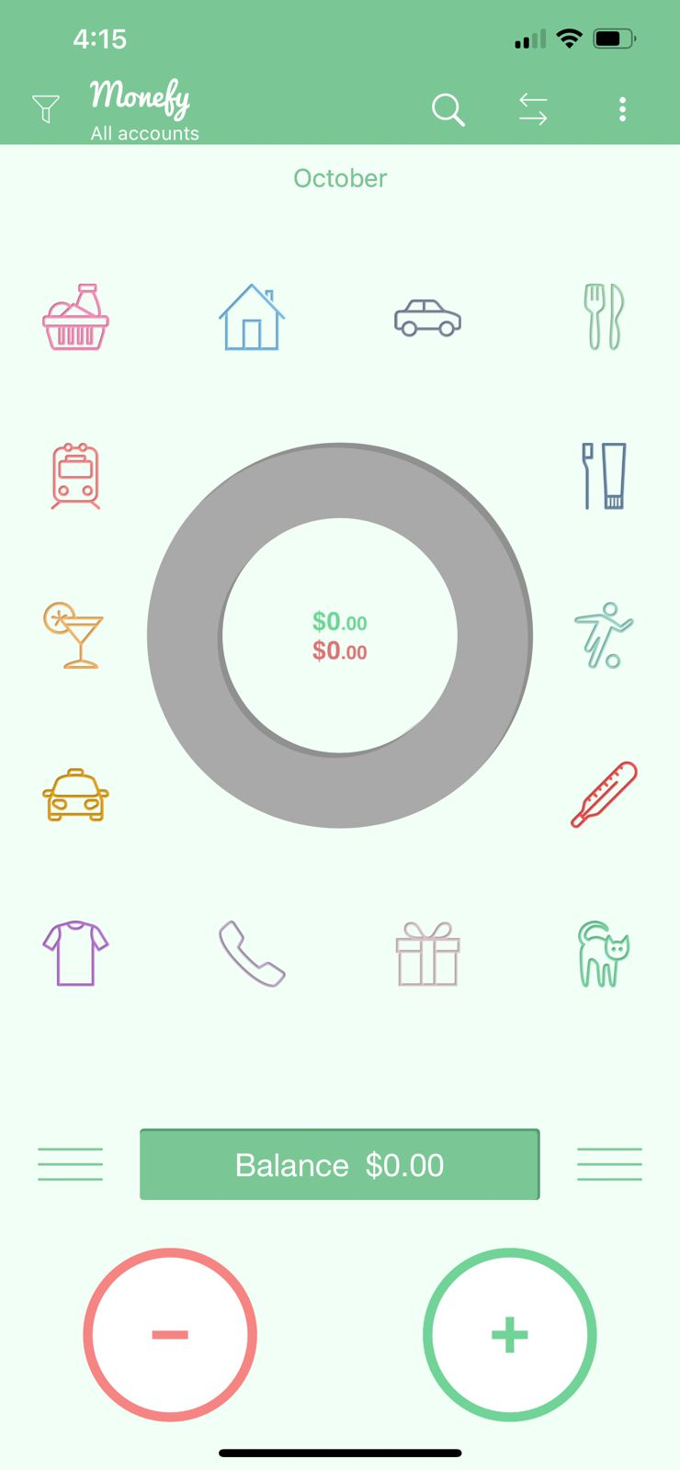

|  |  |
| --- | --- |
| Bug Number | #3 |
| Title | Contact us option not available |
| Reproducible Steps | Open the application – click on three dots on the top right – click on Settings. |
| Affected Devices | IOS |
| Network | Wi-Fi |
| Severity | Minor |
| Priority | High |
| Description | Users can’t get help from the application, a Contact Us button should be available to click on whenever help is required for a bug report or feature request. |

Attachments:

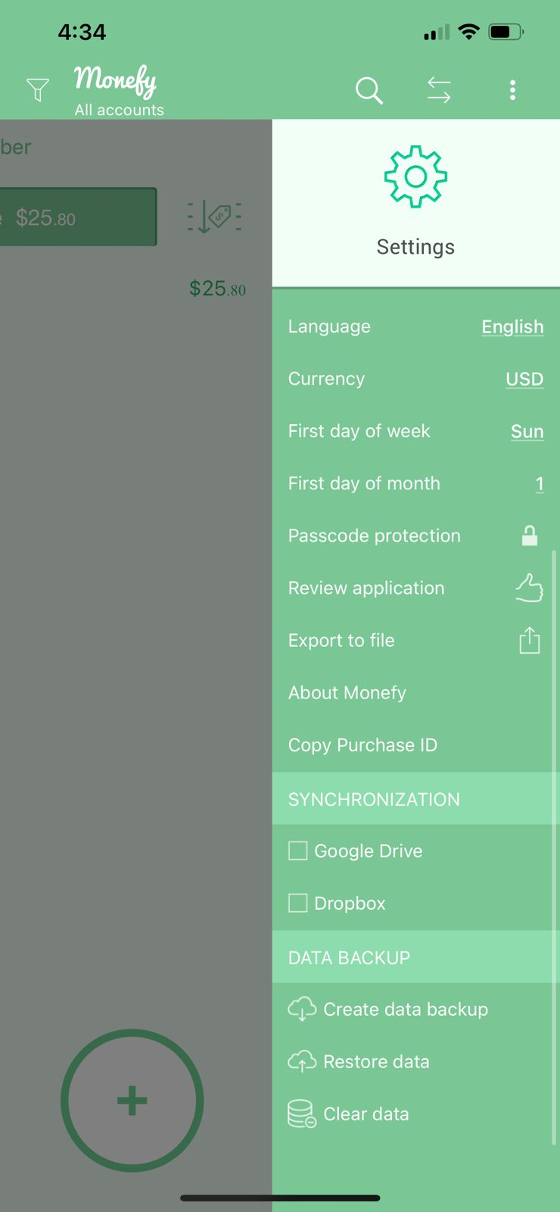

|  |  |
| --- | --- |
| Bug Number | #4 |
| Title | A savings page should be available. |
| Reproducible Steps | Open the application. |
| Affected Devices | IOS |
| Network | Wi-Fi |
| Severity | Minor |
| Priority | low |
| Description | Users should get a Savings page in order to display the amount of money they saved each month or what they wish to save. |

Attachments:



|  |  |
| --- | --- |
| Bug Number | #5 |
| Title | Hide the visibility of balance option. |
| Reproducible Steps | Open the application – click on three dots on the top right – click on Settings. |
| Affected Devices | IOS |
| Network | Wi-Fi |
| Severity | Minor |
| Priority | Medium |
| Description | Users should be able to hide their balance number as a part of data protection, for example: when they click on eye button the balance should be blurred. |

Attachments:

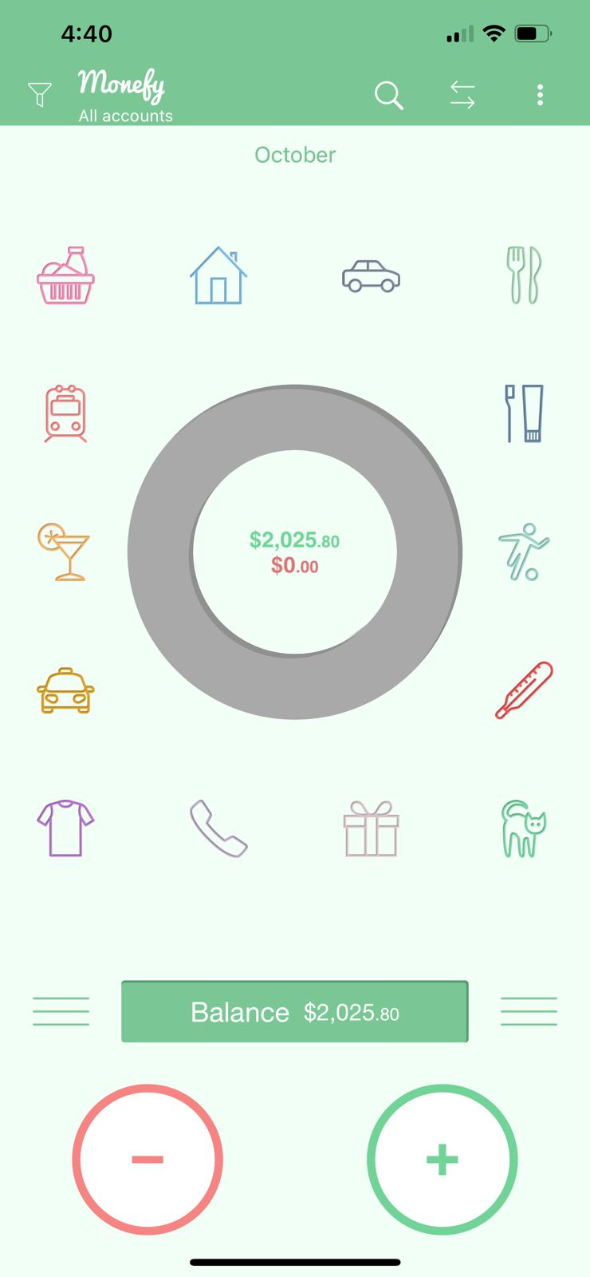

|  |  |
| --- | --- |
| Bug Number | #6 |
| Title | Financial calendar for monthly payments or bills. |
| Reproducible Steps | Open the application. |
| Affected Devices | IOS |
| Network | Wi-Fi |
| Severity | Minor |
| Priority | Medium |
| Description | Users should be able to view a calendar for their monthly income or expense transactions to be more organized |

Attachments:

